107021104 王子銘 計算攝影學 HW1

2.1 Exploration：

a. (The code is in HDR_functions.py的2.1a & draw.py)

The meaning of these figure is：given N張不同曝光時間的圖片，我們可以畫出所有 sample pixel’s pixel value v.s. log(exposure time)的圖(一條curve代表一個 pixel), and we want to concatenate all these curve into one curve(or a table), called EstimateResponse function g(z), z in [0,255], we can achieve this goal by shifting each curve by log(E_i), moreover, we want to 增加某些點(pixel value接近127的點)對於 g(z) 的影響力, we can achieve this by consider weighted function

上面的 response function 將所有點都畫出來，下面只取5個點(點取的方式是隨機的)並組合成 radiance map g(z)

Take channel B for example (剩下的在圖片在 MyHDR_result/2-1a_3_channel 中)

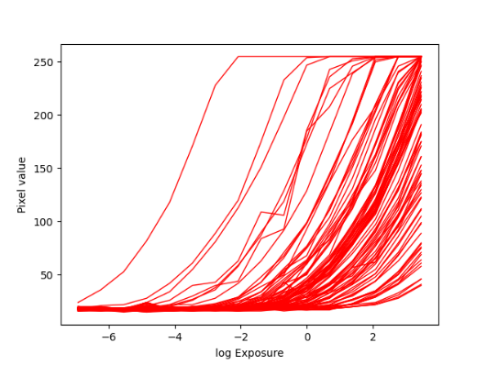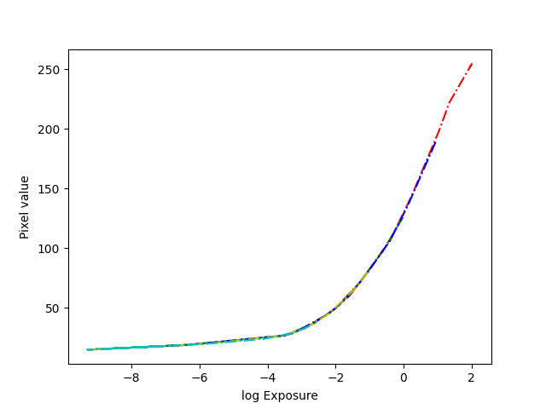

b.

At the step of local tone mapping, why bilateral filter can eliminate halo effect, but gaussian filter cannot?

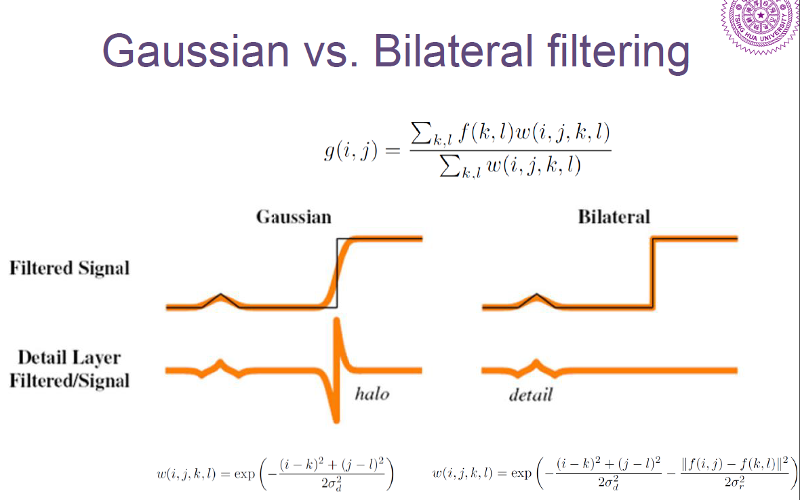

Because the bilateral filter has a additional term, 這會讓 filter 出來的 signal 在 cutoff edge 附近上升更快，所以減出來的 detail layer 就比較不會有 halo effect

c.

Create your own HDR image. Photograph a bracketing set of exposures for a designed scene and perform the HDR imaging flow. Generate at least three HDR images using different tone mapping methodology in the flow. i.e. Run the flow with global tone mapping, local tone mapping with gaussian filter, and local tone mapping with bilateral filter. Provide at least the following information in your report.

i. Your bracketing images and result HDR images

**sample images：**

(按曝光時間長短從上到下，左到右)

白平衡中，選擇作為白色的區域是乒乓球的下半部(沒有logo的部分)

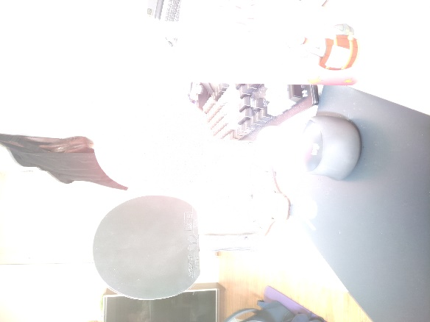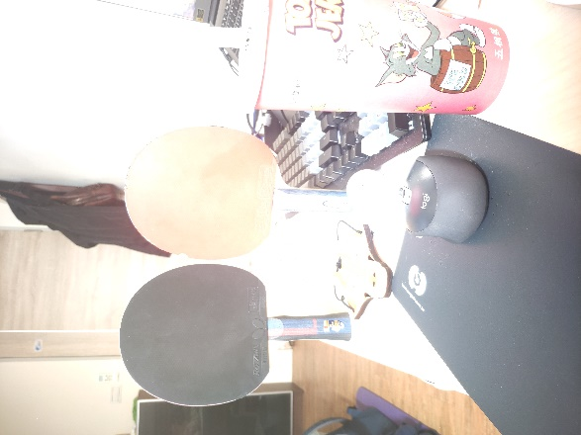

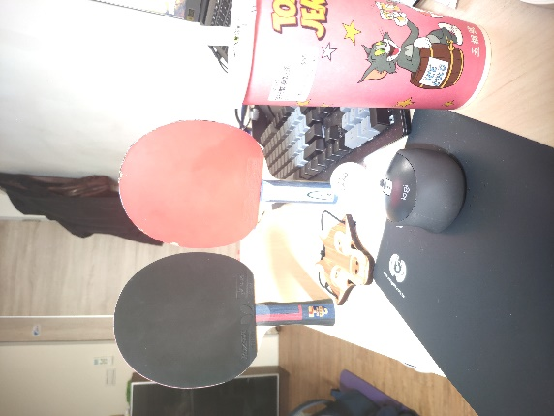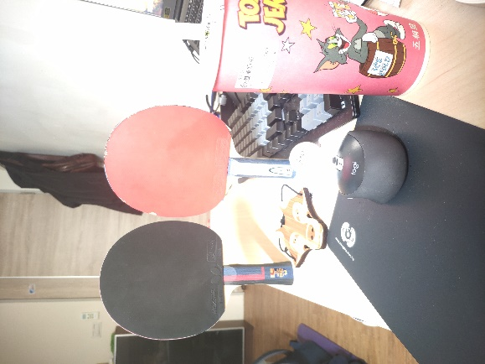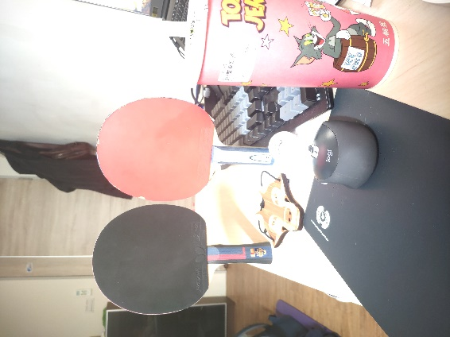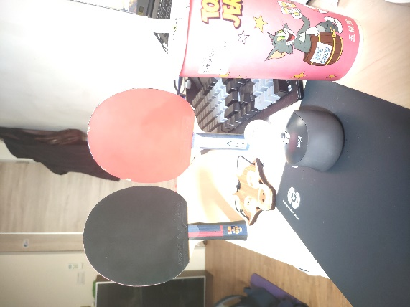

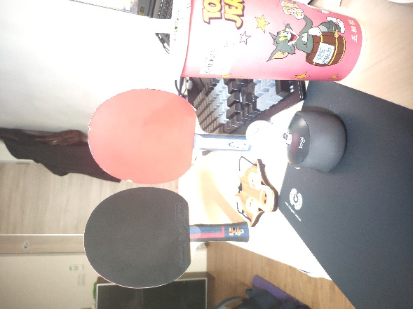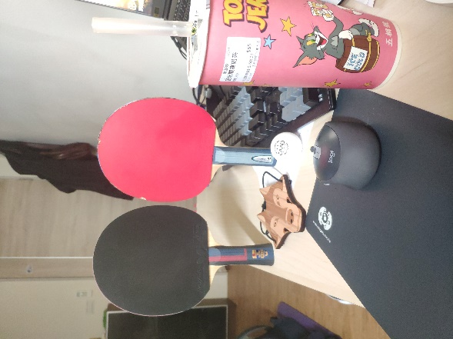

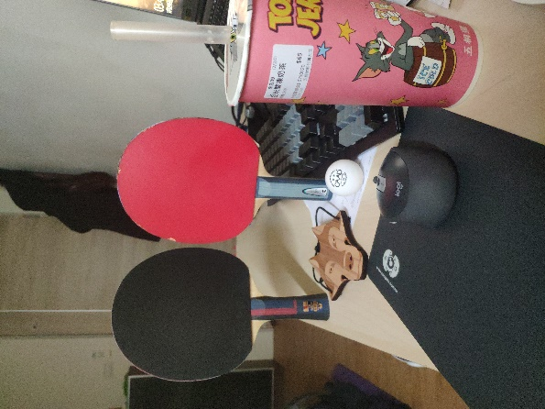

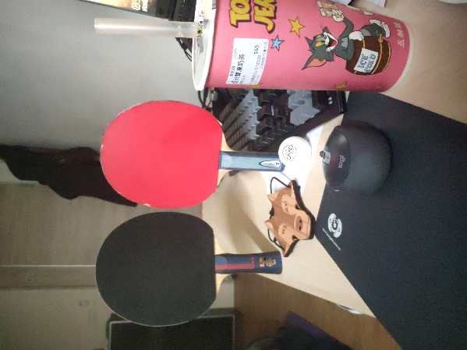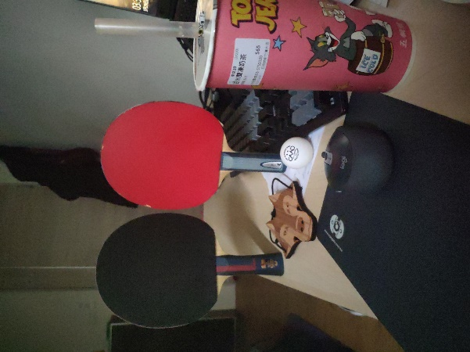

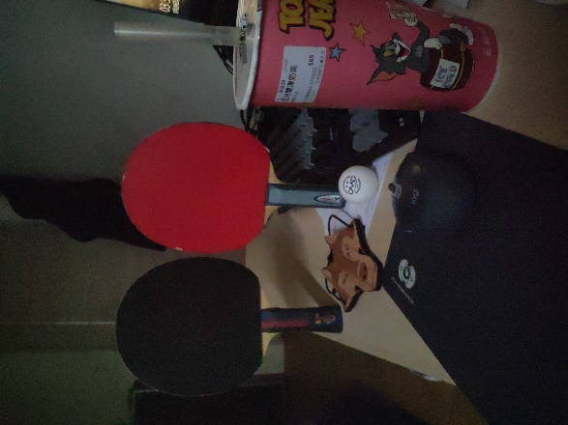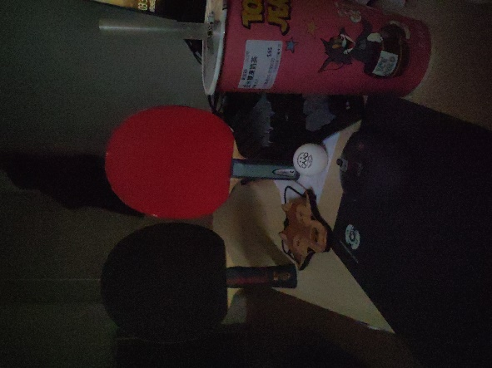

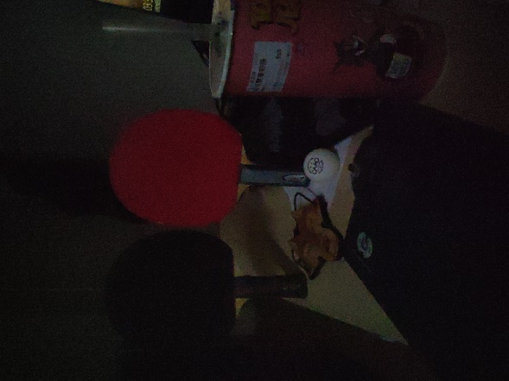

**result images：(in MyHDR_result/)**

**global tone mapping(with/without white balance，有白平衡的圖片牆壁會黃一點，但幾乎沒有差別)**

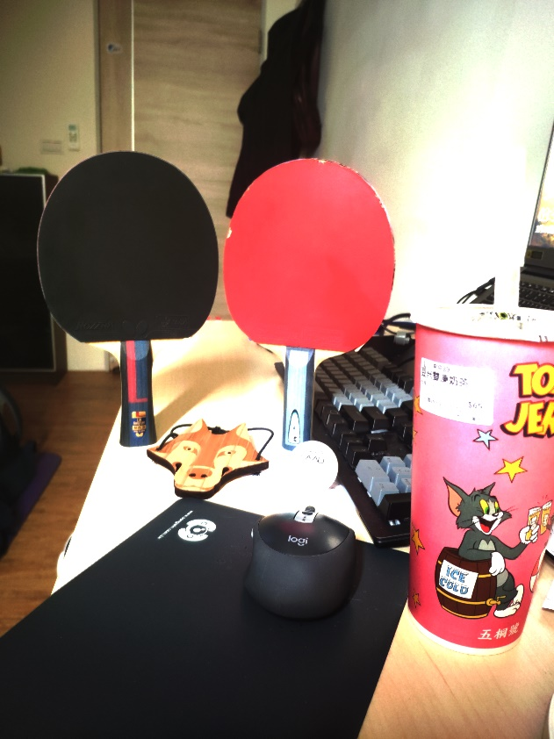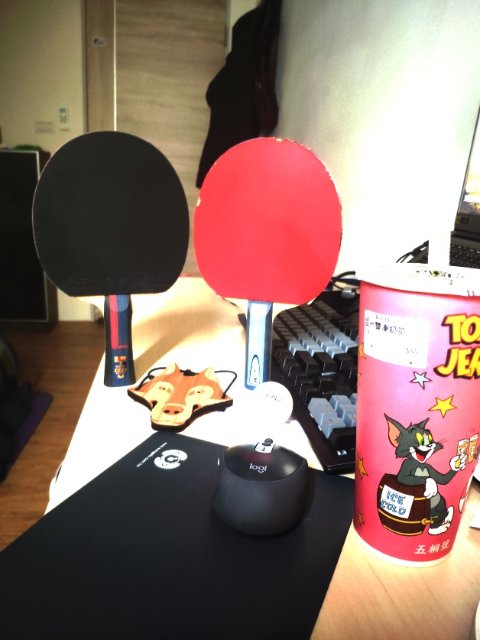

**Local tone mapping(gaussian v.s. bilateral filter，bilateral 偏黑)**

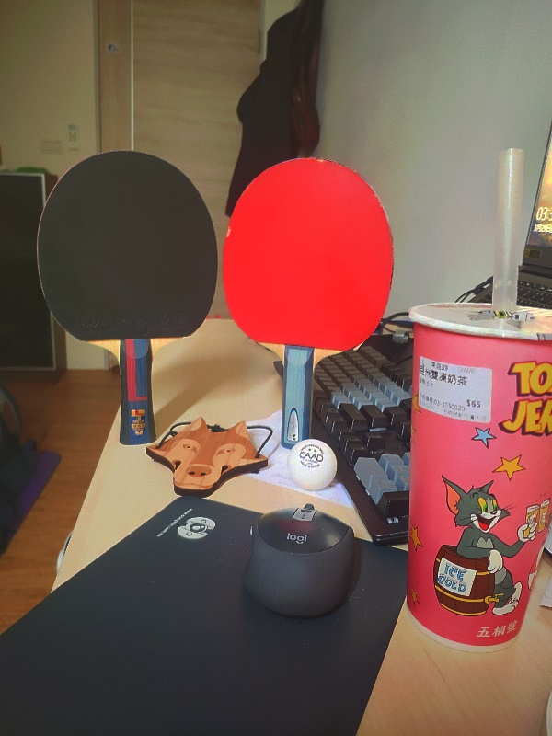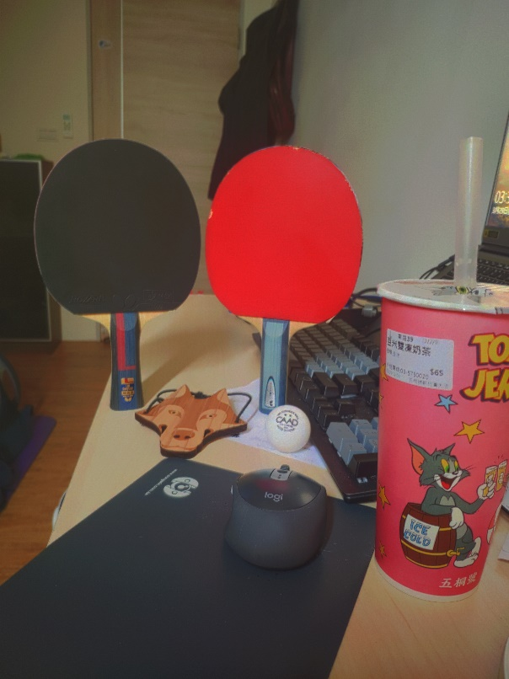

ii. How do you choose the scene?

我拍攝的時間在下午3點半左右，此時的照進房間的陽光不會像中午一樣太大，但又讓我足夠在曝光時間32秒的情況下達成過曝(我想要儘量捕捉多一點細節)，下圖是我在下午六點左右拍的，曝光時間一樣是32秒，但就無法達成這樣的效果

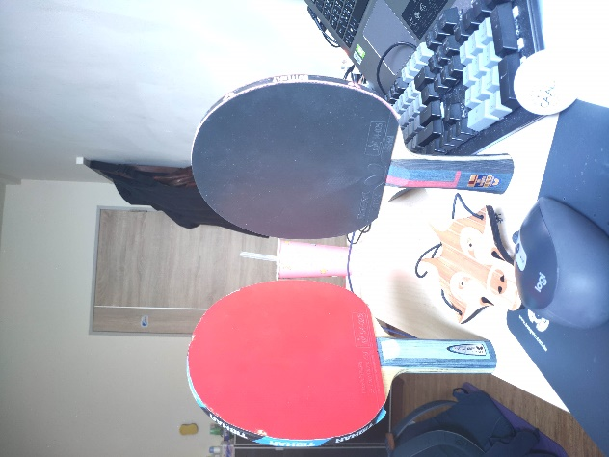

接者場景的選擇上，每張照片我都是對焦在狐狸頭的地方，我用這個點當作對焦的點是因為我希望能將拍子的細節拍得清楚一點，包括拍柄上的logo以及拍皮上的文字

iii. What are your settings of camera when photographing?

e.g. exposure time, shutter speed, f-stop, …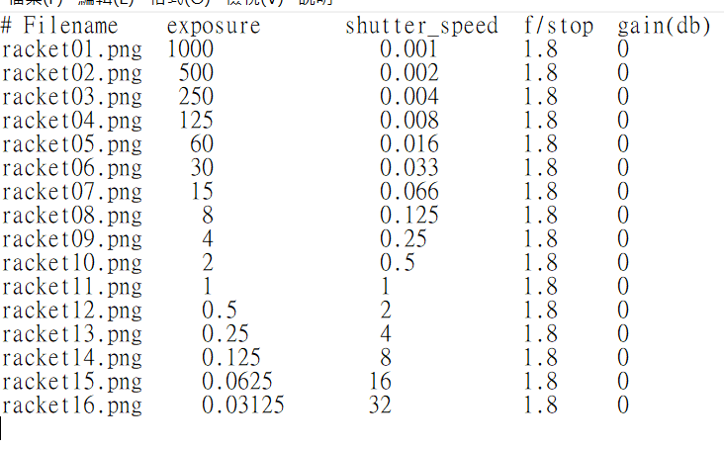

iv. How do you decide the parameters in the HDR imaging flow?

我用的是跟 HDR flow 中一模一樣的參數，由於我跑完整個流程要花 6000 秒

所以我就只做了這一次

2.2 Research Study：

a.

from the following equation，we know the smoothness term of response function is determine by 相鄰兩點的值



Assumption：without smoothness term g’’(z), the radiance map will no longer be a (smooth)curve.

Justification：

Take channel B for example, 剩下的圖在 MyHDR_result/Research_Study_1 中, Response function 如下：

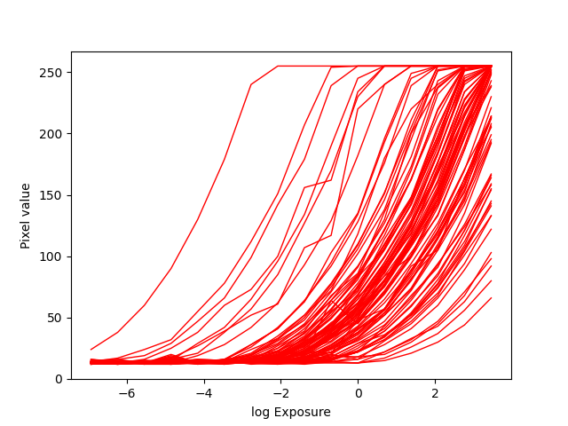

radiance map with smoothness term for 5 pixel(randomly selected)

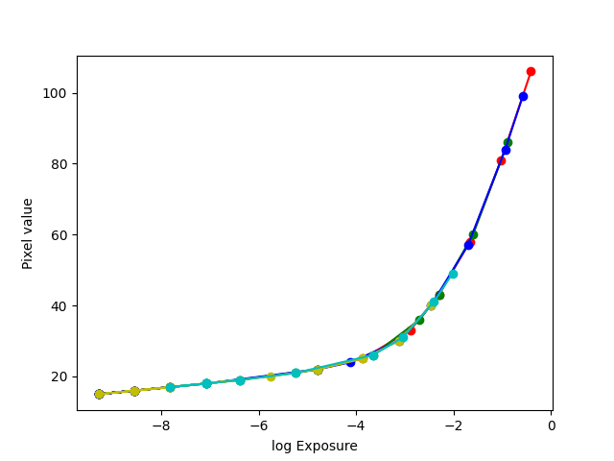

radiance map without smoothness term for 5 pixel(randomly selected)

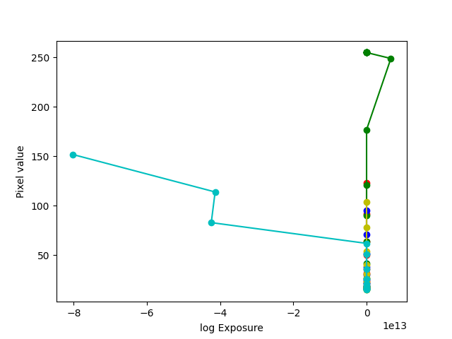

從實驗結果可以發現，的確如假設一樣，經過多次(隨機取點)的測試，在少數情況下 radiance map without smoothness term 有可能變成 smooth curve，原因尚未釐清

b. (圖片都在 MyHDR_result/ Research_Study_2 中)

assumption：

by equation below

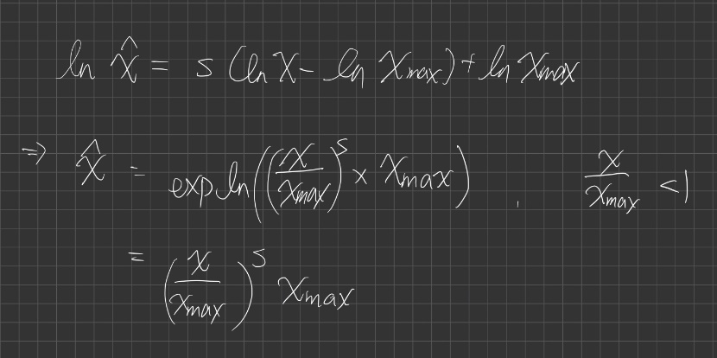

In global tone mapping , scale 越大，得出的 X_hat 越小，所以畫面的整體亮度應該會比較暗

by equation below

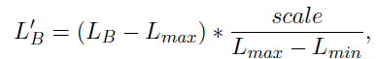 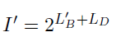

In local tone mapping , scale 越大，得出的 base layer 整體數值越小，所以畫面的整體亮度應該會比較暗

Justification：

不論是 global tone mapping or local tone mapping，scale 越大，跑出來的畫面整體越暗，越小越亮

**Case：global tone mapping**

左邊有 white balance，右邊沒有 white balance

Scale = 0.5 => 兩張都全白

Scale = 0.75

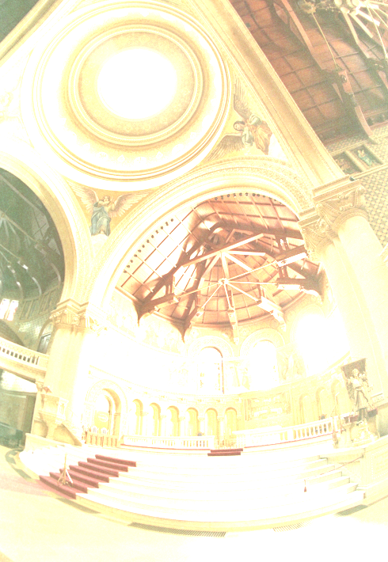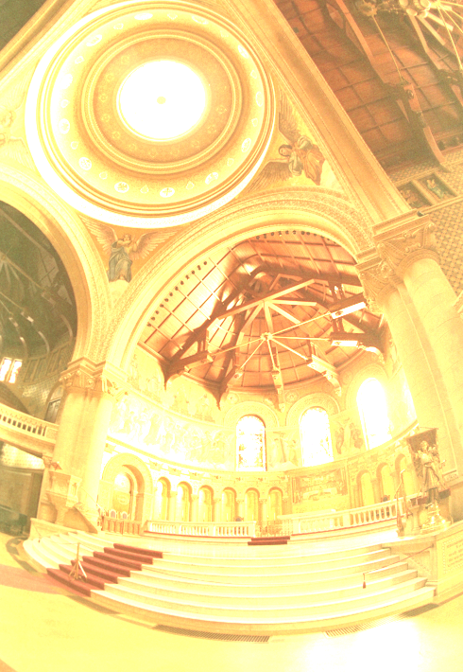

Scale = 1(default)

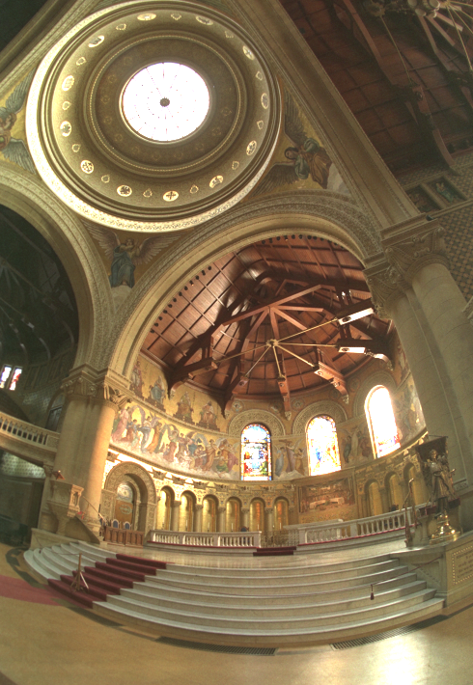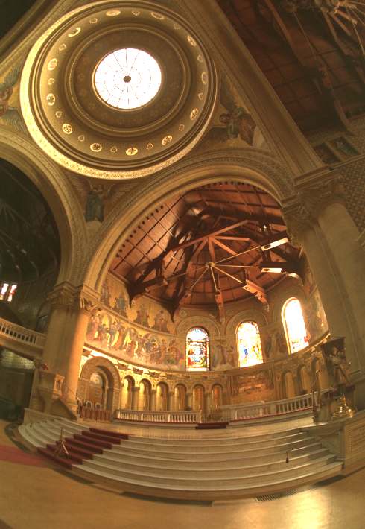

Scale = 1.25

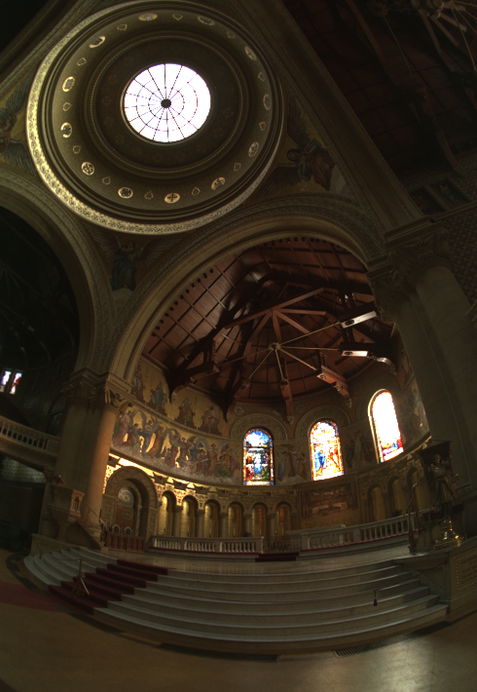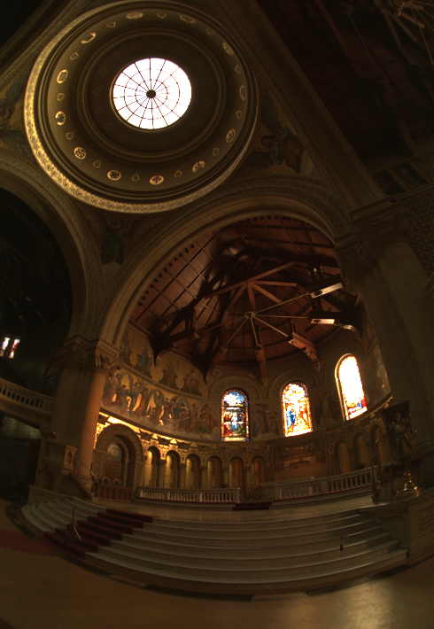

Scale = 1.5

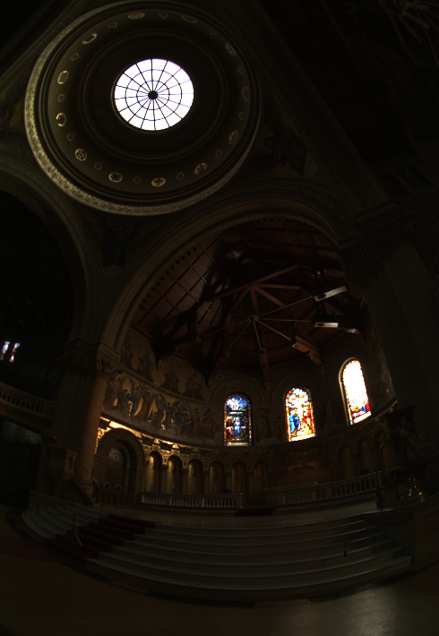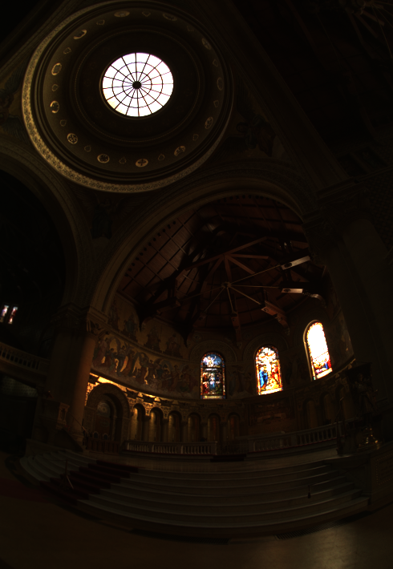

**Case：local tone mapping (Gaussian filter)**

Scale = 左3 右5

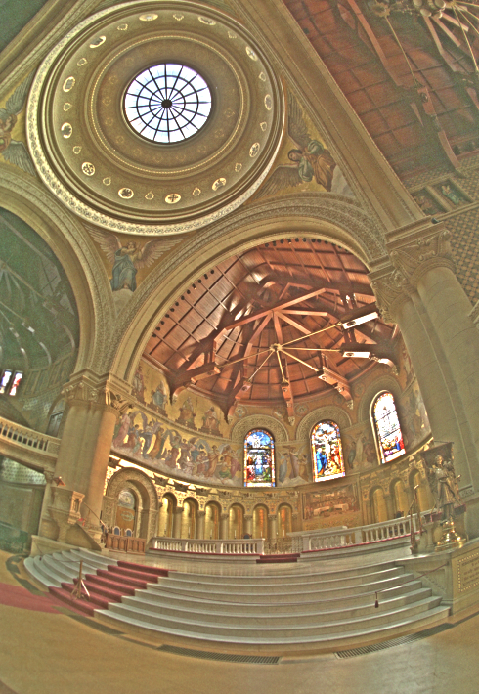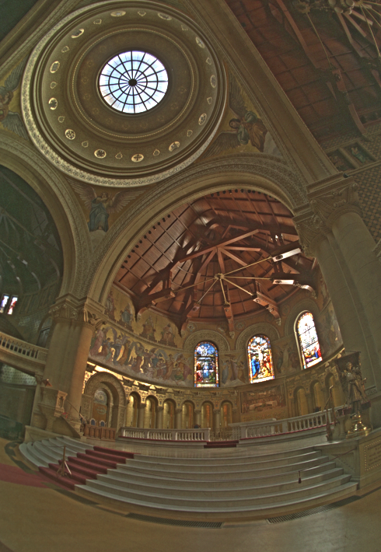

Scale = 7 (default)

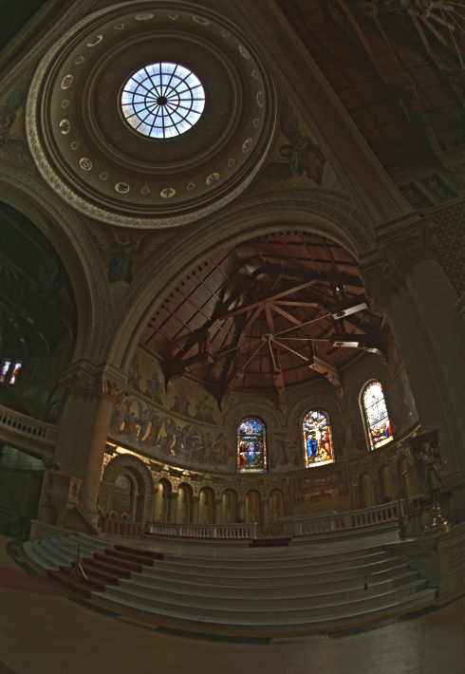

Scale =左9 右11

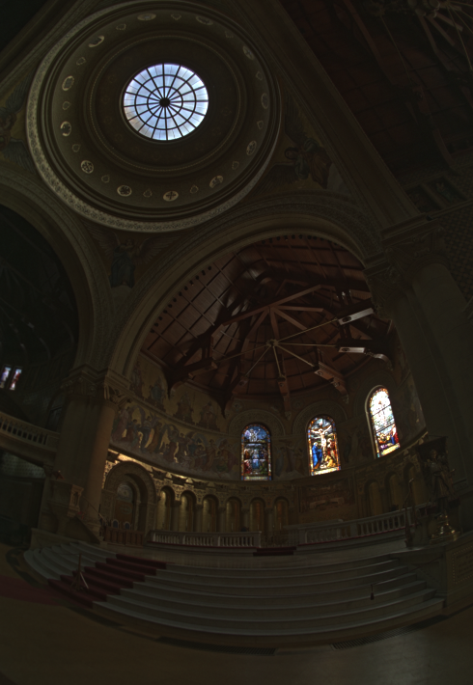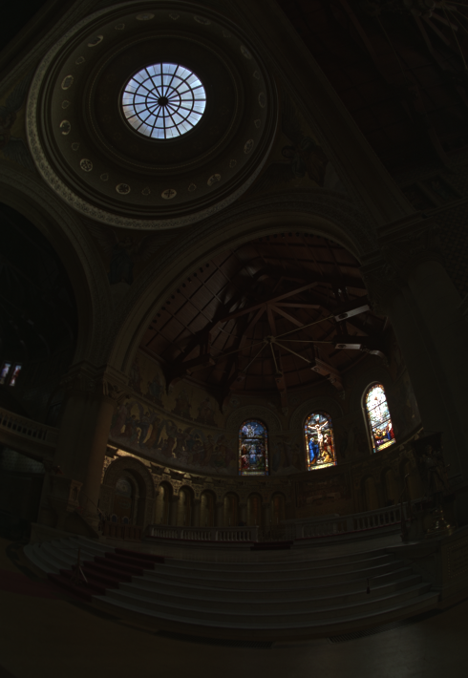

**Case：local tone mapping (bilateral filter)**

Scale = 左3 右5

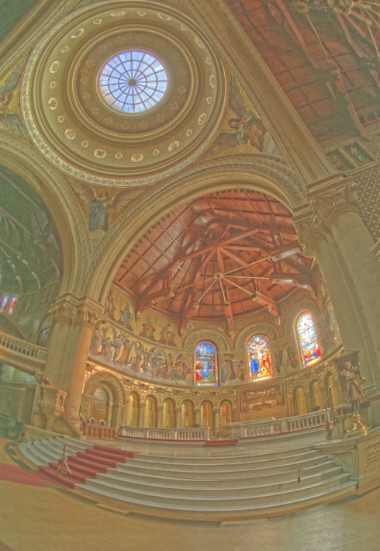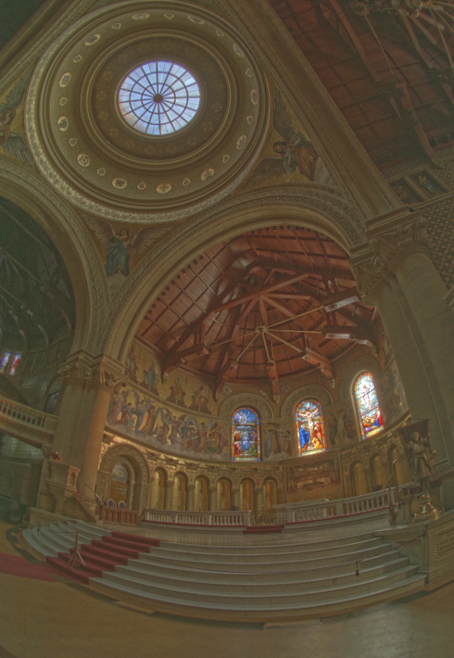

Scale = 7 (default)

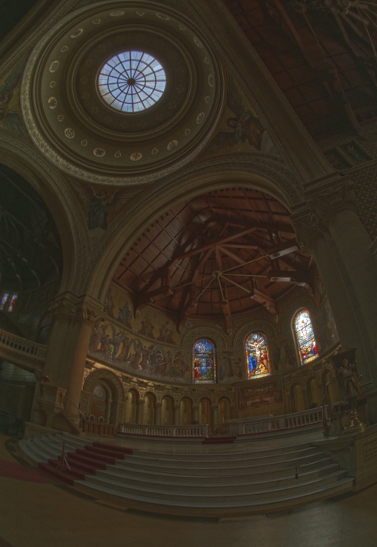

Scale = 左9 右11

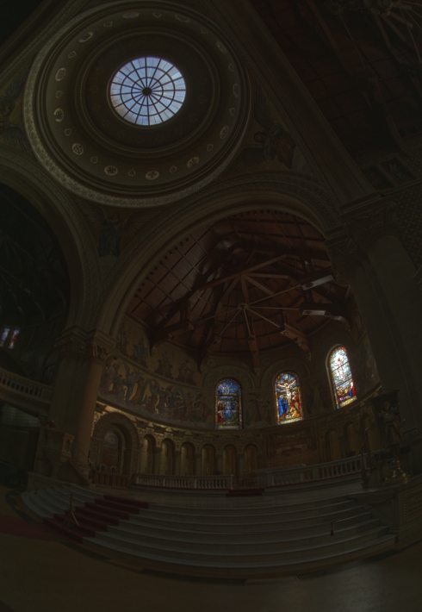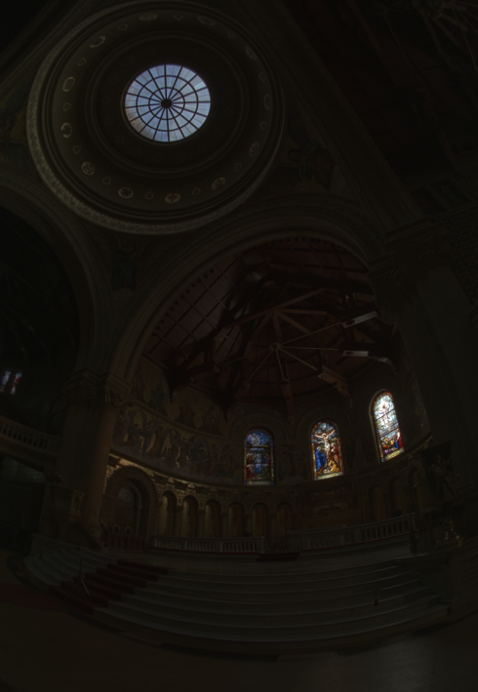

c. (圖片在 MyHDR_result/ Research_Study_3 中)

We can fix G & B channel value and modify the other two channels instead，結果如下：

global tone mapping Fixed R channel (default) v.s. no white balance



global tone mapping Fixed B channel v.s. Fixed G channel

